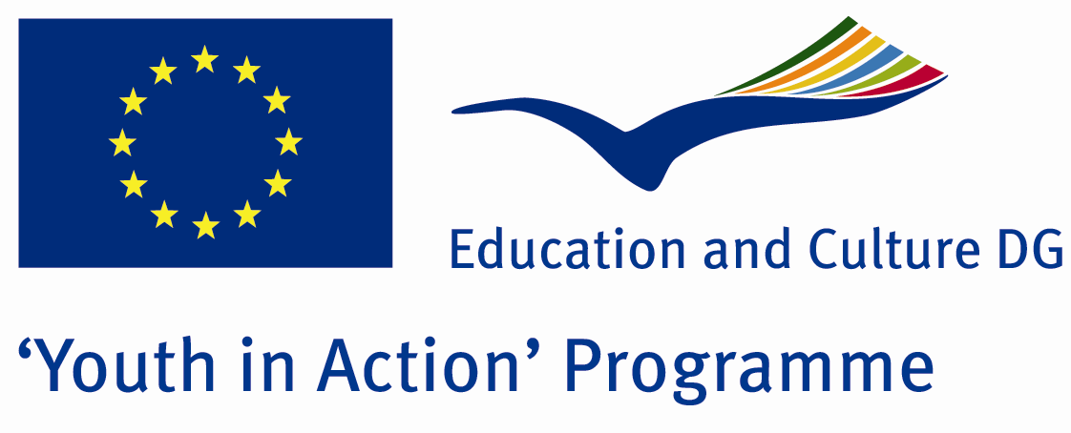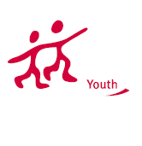

The light of republic



ACTION 1.1 – Training And Networking

24-29th October , 2011

Aydin, TURKEY

ACTION 1.1 – Training And Networking
Aydin, TURKEY

Please contact directly to;
adventurerpeacepigeons@gmail.com

Project Summary;

In this Project, we will try to teach all the methods of the managements to our participants…. Our participants will be youngsters people between 18-25… So, they will learn the importance of democracy… Because according to us, the best moethod of management is democracy… Democracy tries to give freedom to all the people… of course if you use it well… In fact, all the methods of managements aim the same thing.... all of them want to people live in easy circumstances… But their ways are different… and during all the historical times, the people use these management methods but they accept the democracy as the best… In this Project, we will try to teach all the managements methods and we will try to find the answer of this question: which one is the best? what importance of the democracy? And how will these information about the methods help you? And we want to make this project with you… we want to see you as our partner in this Project…

Project Title; The light of republic

Date and Venue ; 24-29th October , 2011
Aydin, Turkey .

Target Group ; Municipalities, City Councils and Non-Governmental organizations,
youth groups,culture and art groups,e.t.c

Participants ; 5 people from each country (over 18 -25 ). Totally 8 countries.

Conditions ; Accommodation, board and programme costs will be financed through European Commission Youth in Action Programme ….Travel costs will be reimbursed in 70% (APEX Tarrifs). Organizations from all 27 EU member countries plus Liechtenstein , Norway and Iceland are eligible to take part.

Working language: English

Organizer; Adventurer Peace Pigeons

How to apply: If you are interested, please send your Part III forms to
by e-mail please. Scan Part3 format is enough for application. (Fulfilled Part III which you can find in the attachment, of course signed and stamped) ..

Next step 2;
Original send via regular post to this address please:

Ertan DERİN
Fevzi Çakmak Mahallesi Tuncer Sokak No:6 PENDİK/İSTANBUL/TÜRKİYE
e-mail : adventurerpeacepigeons@gmail.com
Mobile : 0090 542 393 93 90

If you have any questions you may contact with: adventurerpeacepigeons@gmail.com

Deadline for application; until 15th may 2011.

For Further information:
Contact Person
Ertan DERİN
Fevzi Çakmak Mahallesi Tuncer Sokak No:6 PENDİK/İSTANBUL/TÜRKİYE
e-mail : adventurerpeacepigeons@gmail.com
Mobile : 0090 542 393 93 90

